SAVE THE DATE

**E-cigarettes Masterclass**

**With guest speaker:**

**Martin Dockrell**

**Tobacco Control Programme Lead  
Public Health England**

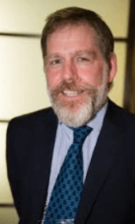

**Thursday 26th January 2017 at 13:00**

**VENUE: Focolare Centre, 69 Parkway, Welwyn Garden City**

**AL8 6JG**

**FREE EVENT**

**Speaker Biography:**

**Martin is Tobacco Control Programme Lead for Public Health England. He joined PHE in February after 7 years at Action on Smoking and Health. Martin has worked in Public Health since the mid 1980s when he was involved in HIV prevention work. He is a fellow of the Royal Society of Public Health.**

**Booking e-mail to:** [**Stopsmokingservice@hertscc.gcsx.gov.uk**](mailto:Stopsmokingservice@hertscc.gcsx.gov.uk) **or call 01442 453071**