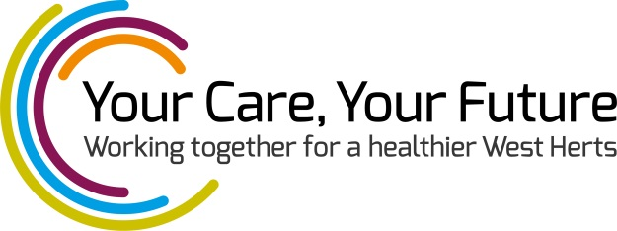
INVITATION
Dear Resident,
NHS organisations and Hertfordshire County Council are developing proposals as part of a major review of the way health and social care services are provided in West Hertfordshire. The review – called Your Care, Your Future – is looking at new ways to provide care and would like your help to design the models of care.
Your local event is being held at:
The Aubrey Park Hotel, Hemel Hempstead Road, Redbourn, AL3 7AF
Wednesday 12 August 2015
9.30am – 11.30am
Many of you have helped us by providing feedback on what services should be provided for local patients, service users and carers. Thank you for your help so far.
We have used your feedback to develop proposals about how local health and social care services could be organised in the future. We want your views. On 12 August we invite you to comment on the proposals, their key features and some example scenarios. This will help us define what services should be provided locally.
To register, please e-mail info@yourcareyourfuture.org.uk to confirm your attendance.
More information on Your Care, Your Future is available at www.yourcareyourfuture.org.uk.

Have you received your copy of Case for Change?
Your Care, Your Future last week published the final Case for Change, which is available here: http://www.yourcareyourfuture.org.uk/case-for-change/. A hard copy can be ordered by e-mailing info@yourcareyourfuture.org.uk.

